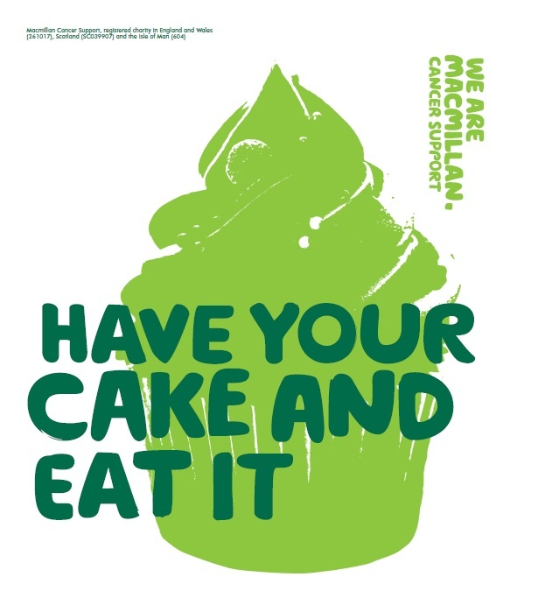
IT’S TIME FOR AN NGA CAKE SALE!


Who: All staff and students are invited (cakes between 20p-50p cash only)
What: Cakes and biscuits will be on sale
When: Break time on Friday 29th September
Where: In the canteen
Why: To raise money for a worthwhile charity

